**CREATION OF NON-VENDOR PRACTICE AND PROVIDER**

Non-Vendor practice and provider means that the practice & provider is only created in novelHealth platform and there will not be any communication of novelHealth with any integrated system. Integrated system in our case is only V10g right now.

**How to create practice through super admin account:**

* First sign in from super admin account ([jim.brown@curemd.com](mailto:jim.brown@curemd.com) / CMDSupport.2K&@)
* Then click on “**Add practice**” on the top right side
* Fill all necessary fields
* Create practice admin

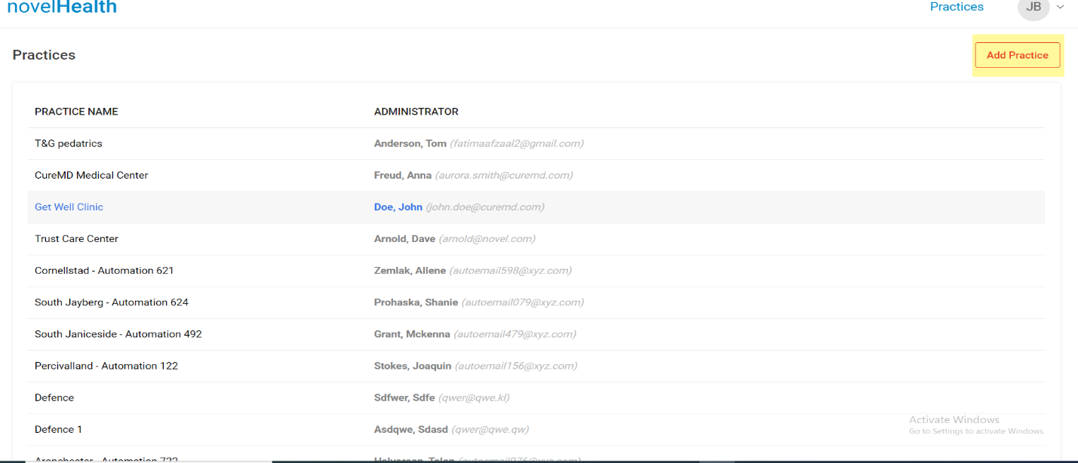

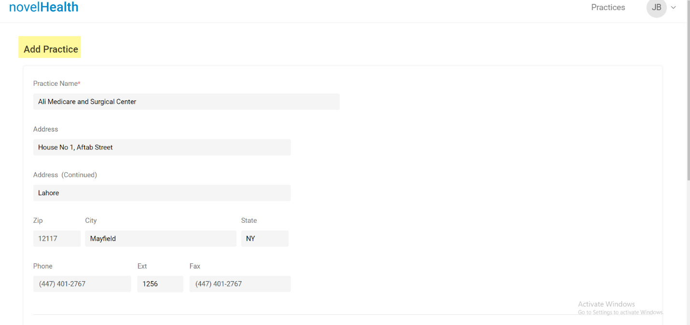

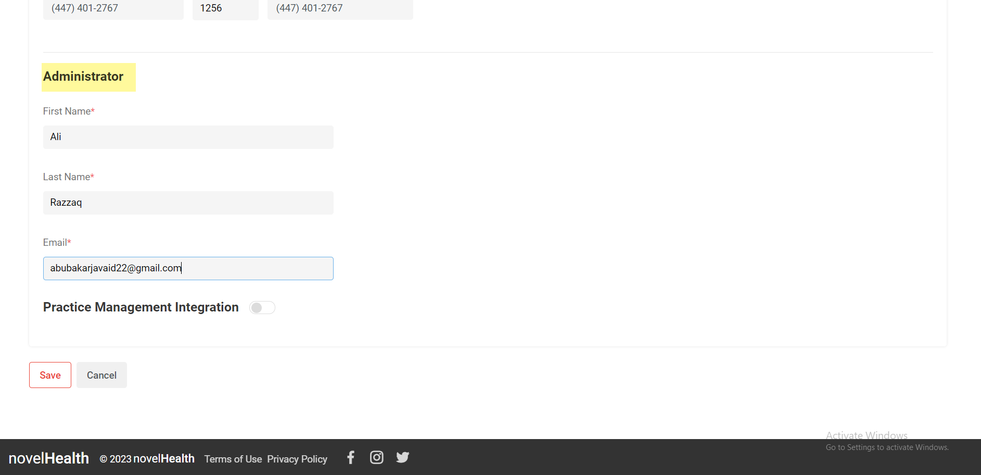

**How to create provider in novelHealth:**

* Verification email is sent
* Use this email to set password for admin login
* Log in to practice admin account
* Click on **“Settings”** showing to top right of profile
* Click on **“Users”** from left panel
* Then click on **“Add Provider”**
* Fill all necessary details of provider
* Then click **“Save”**

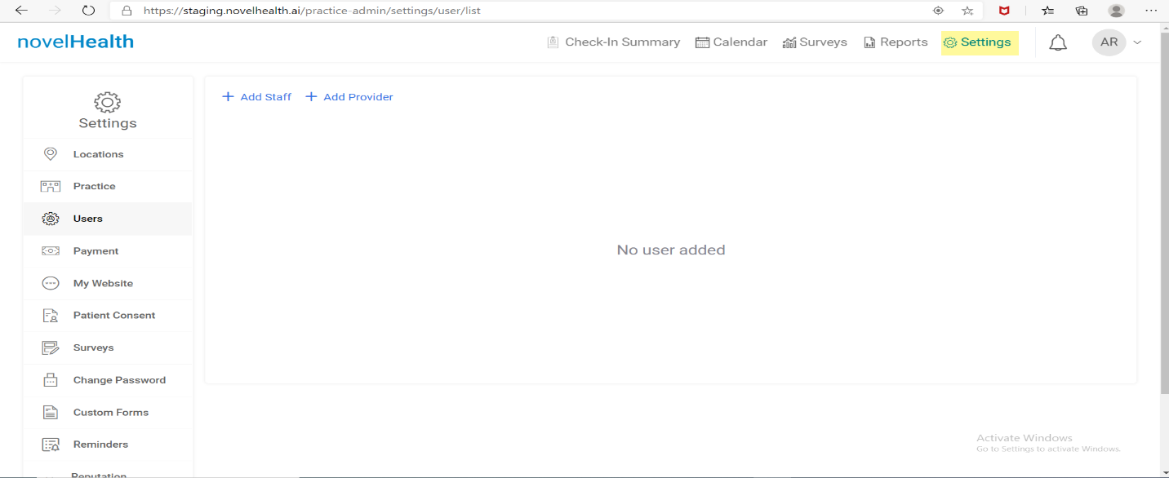

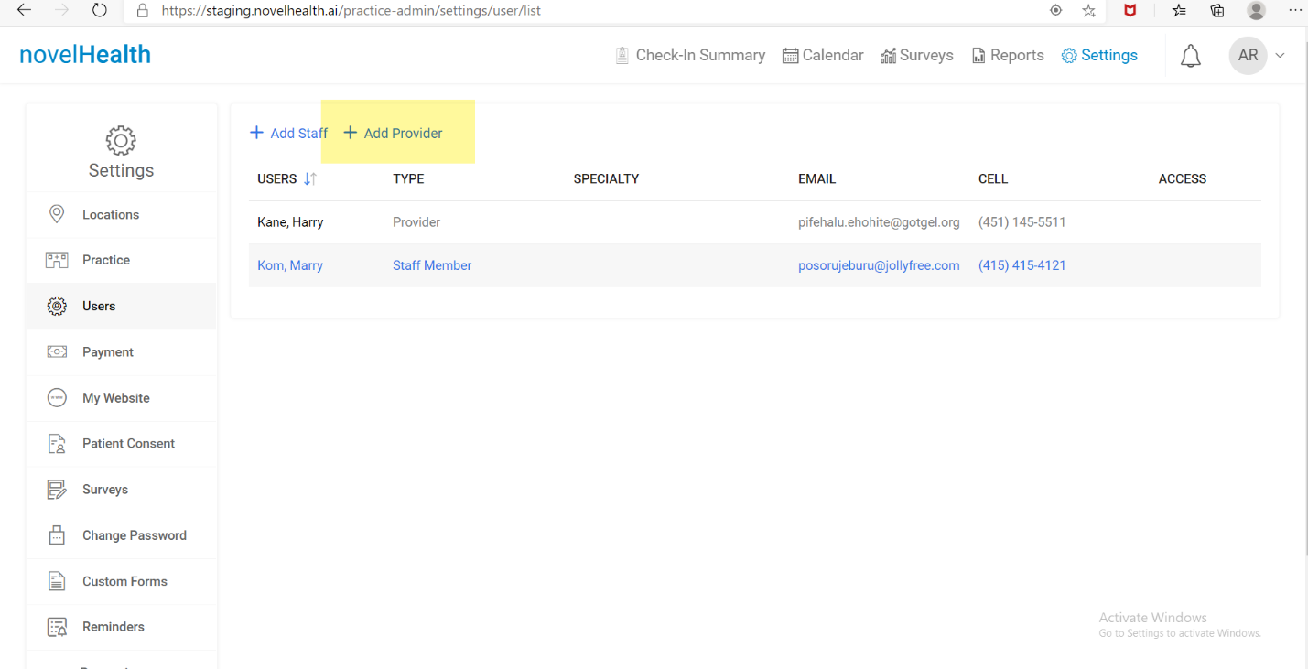

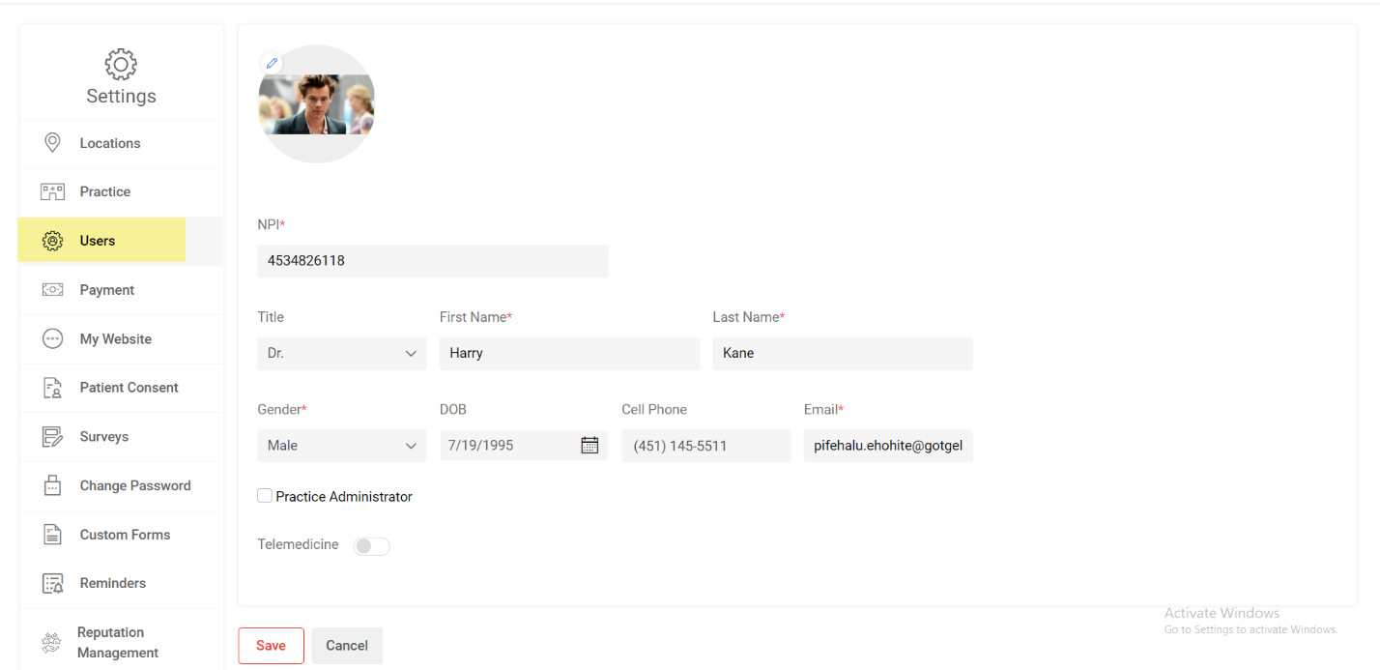

**How to add staff in novelHealth:**

* Click on **“Users”** from left panel
* Then click on **“Add Staff”**
* Fill all necessary details of staff
* Then click **“Save”**

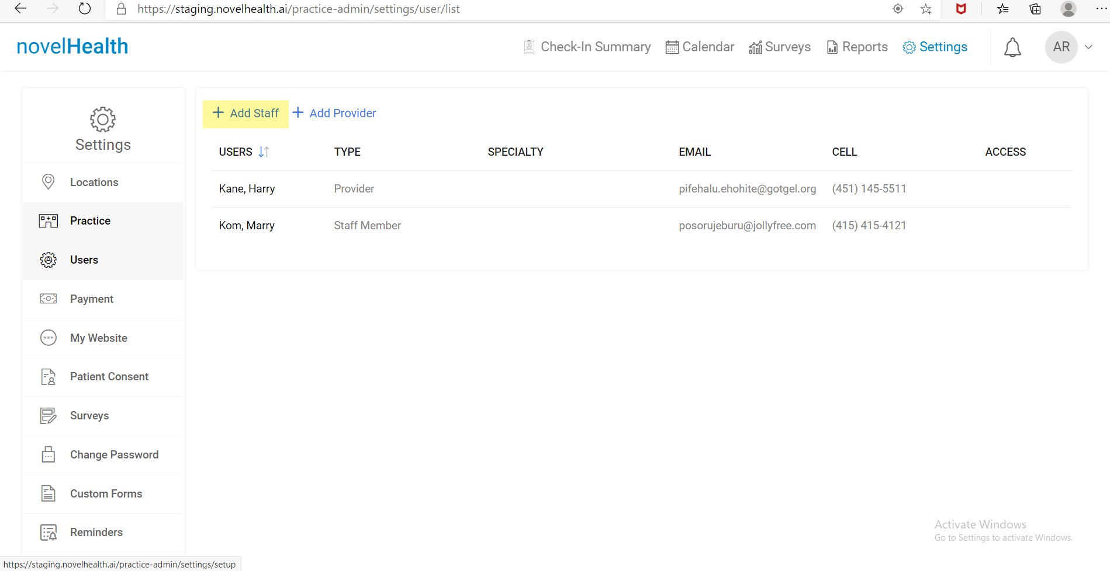

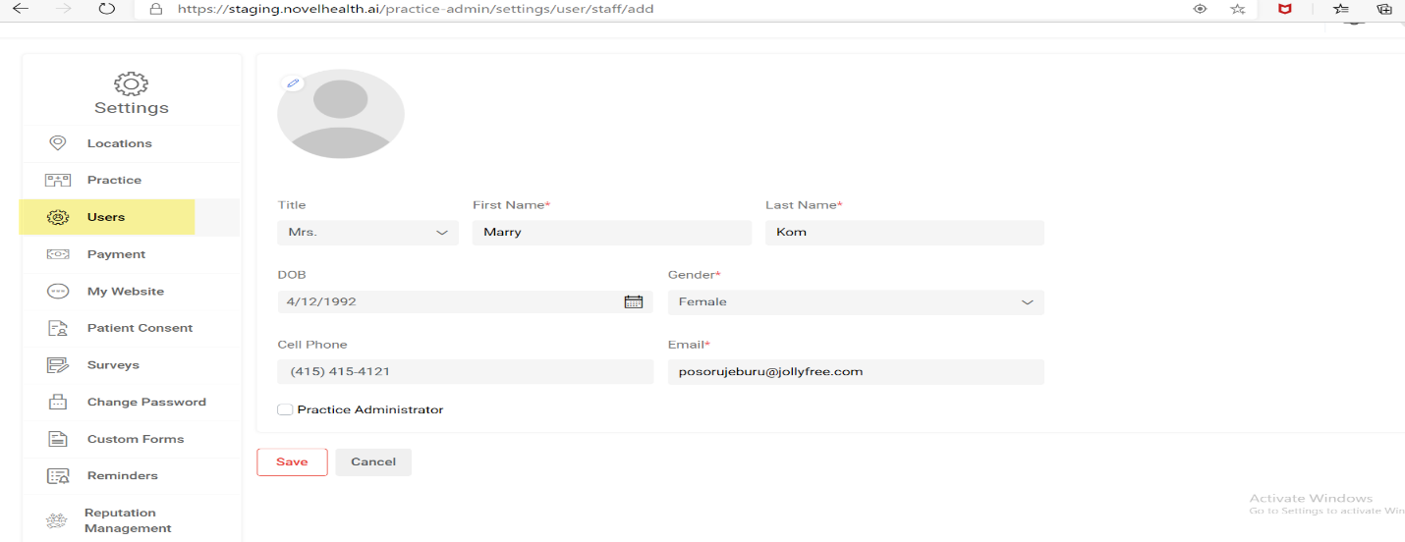

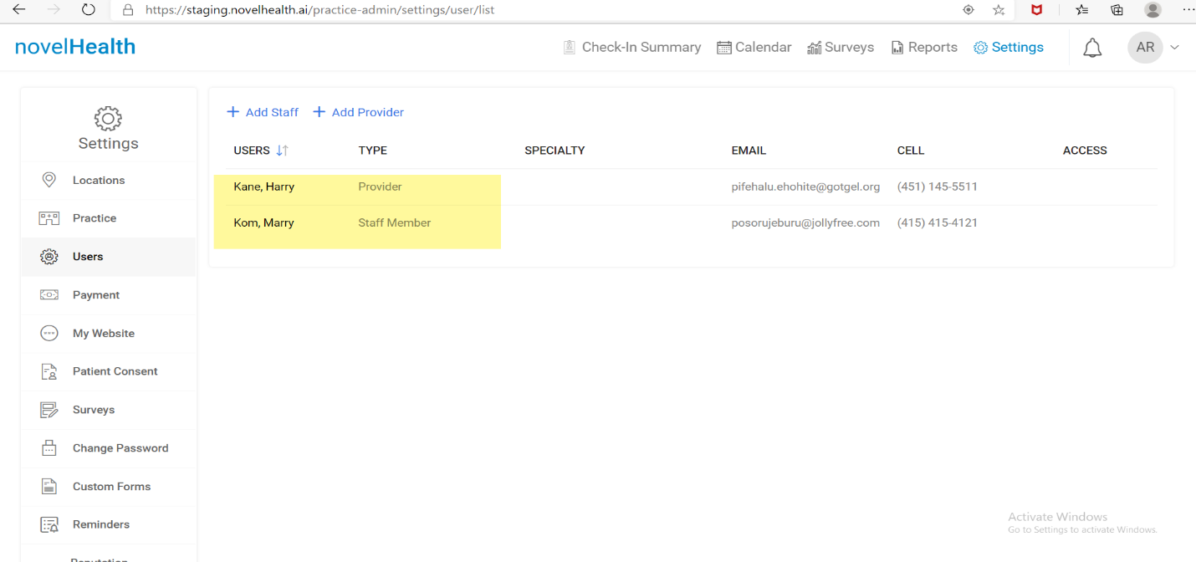

**How to associate staff with provider:**

* From User Panel click on “Provider” which is created
* Click “Account”
* Scroll down
* Enable “Telemedicine”
* Select “Amazon Chime” from dropdown
* Then from “Associate Staff” dropdown click staff which you have created
* Selected staff will be associated with provider
* Then click “Save”

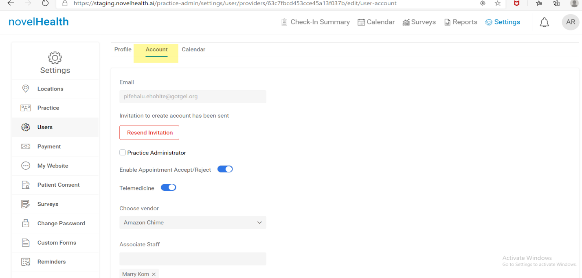

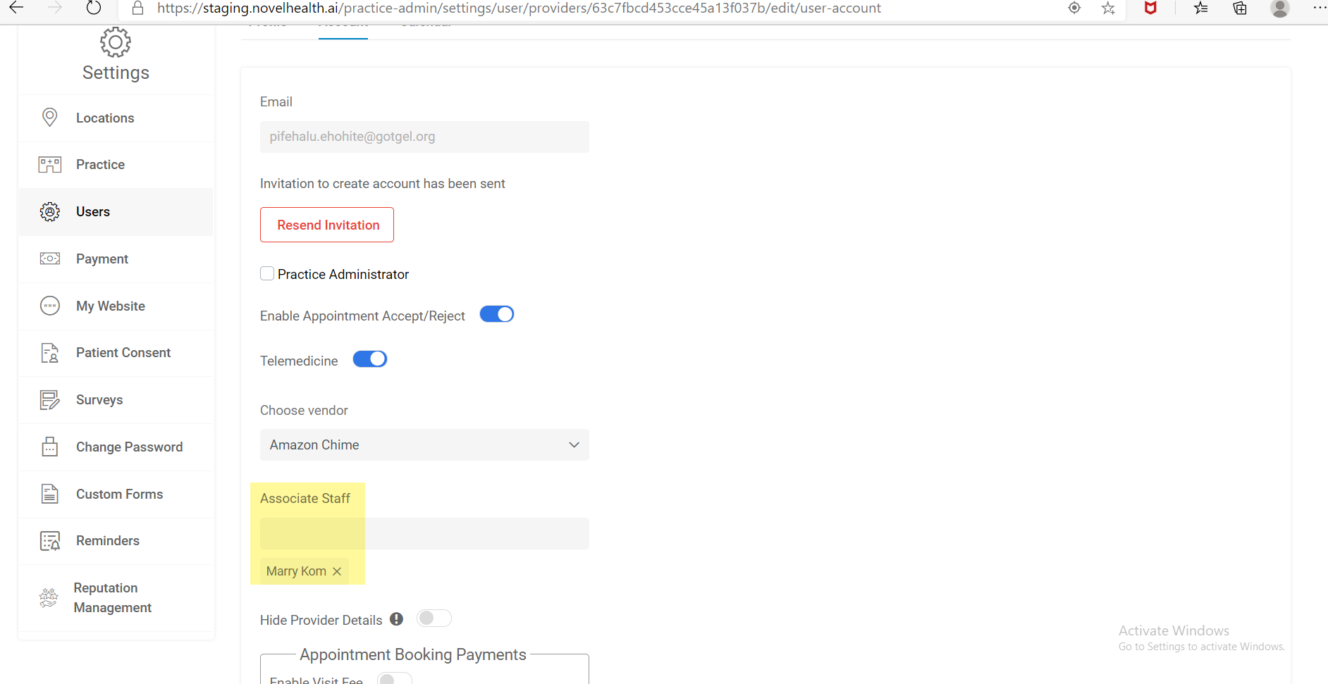

**How to create locations in novelHealth:**

* Click on **“Location”** from left panel
* Then click on **“Add location”**
* Fill all necessary fields
* Then click **“Save”**
* Locations will be added

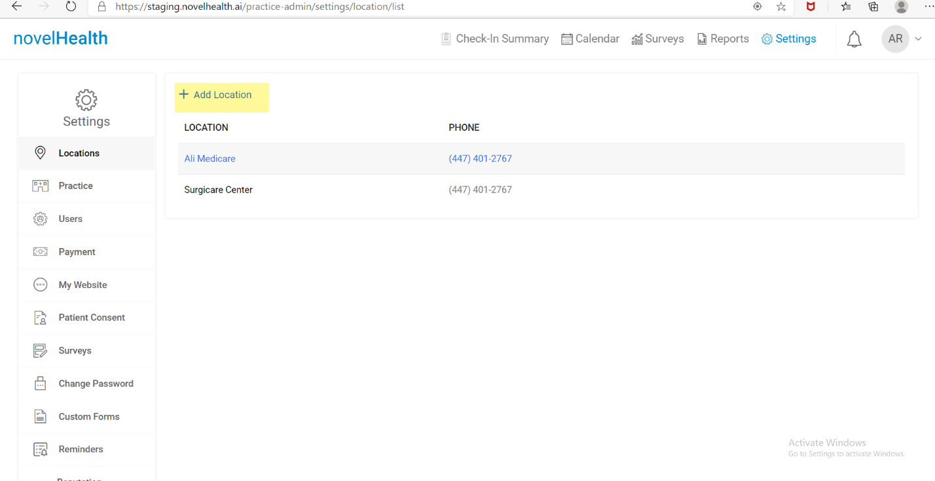

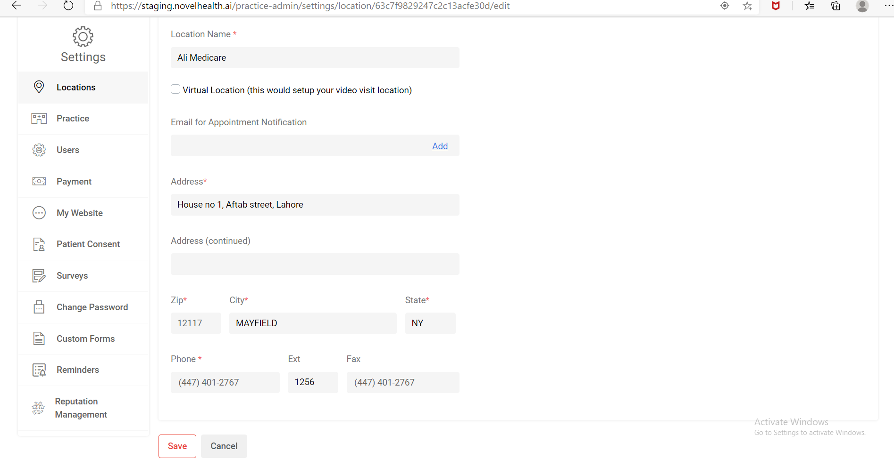

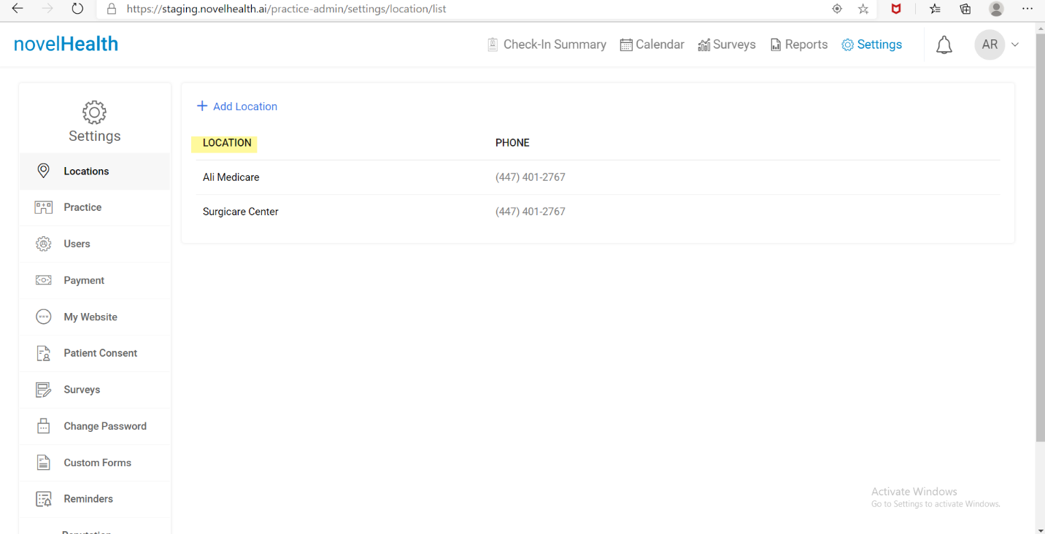

**How to associate location with provider:**

* Click on **“Users”** from left panel
* Then click on **“Provider Information”**
* Click on **“Locations”**
* Select different location where provider will give his expertise
* Then click **“Save”**
* Locations will be added

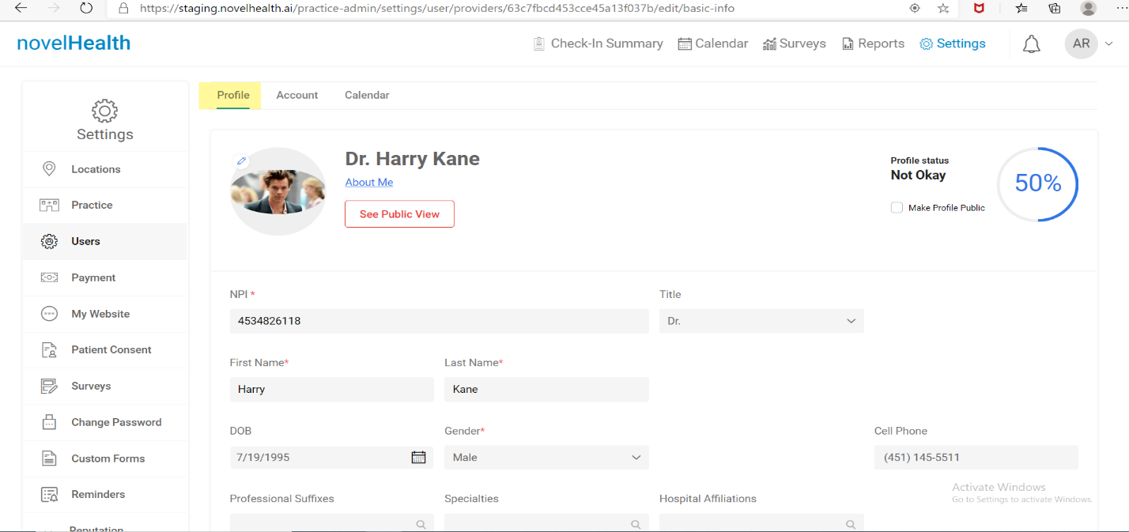

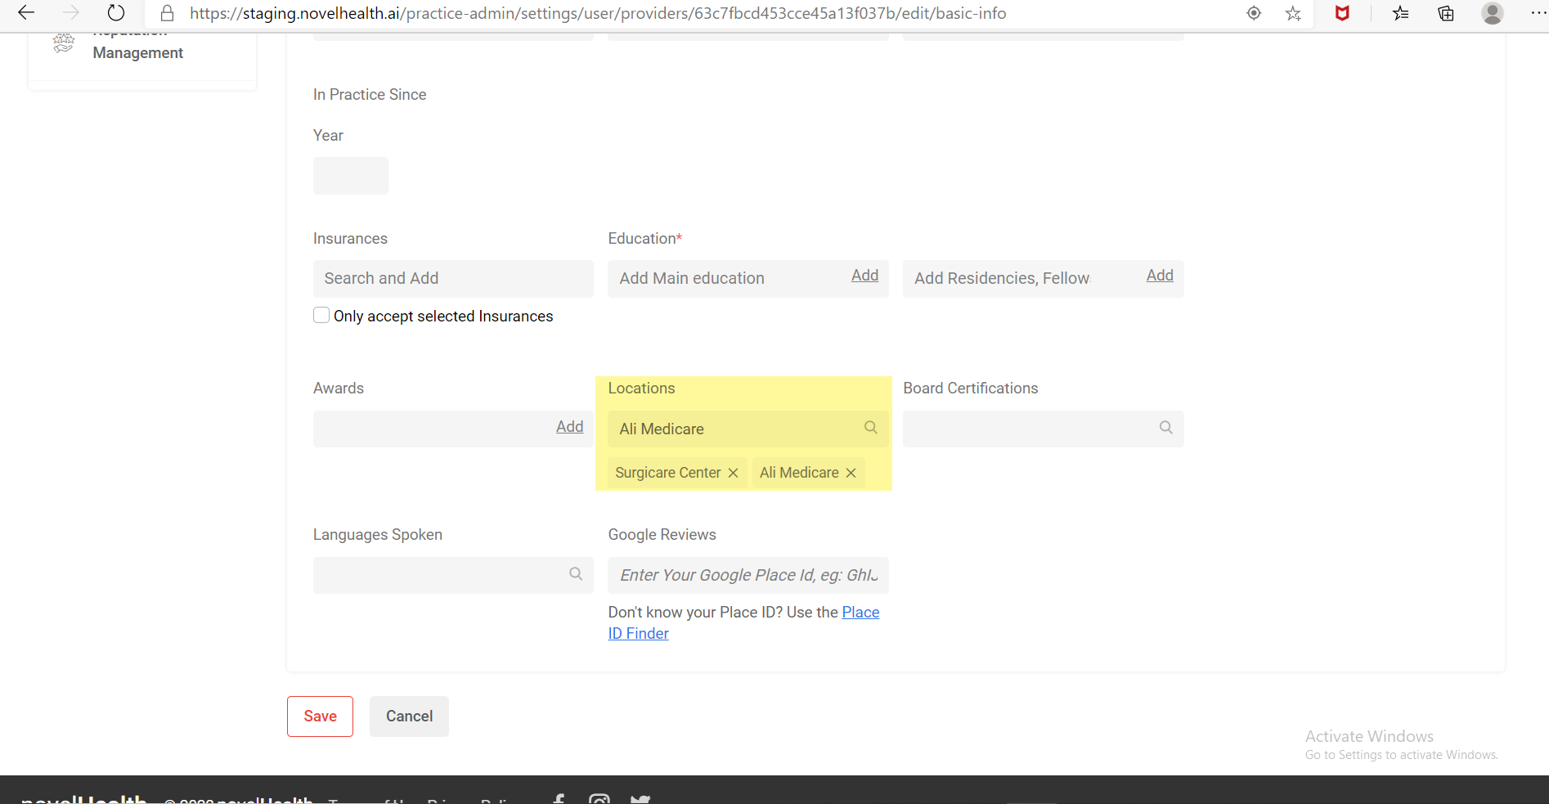

**How to create calendar:**

* Click on **“Users”** from left panel
* Then click on **“Provider Information”**
* Click on **“Calendar”**
* Give name to Calendar
* Set calendar data as required

